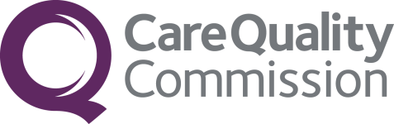
CQC PMS Inspections
Citygate
Gallowgate
Newcastle upon Tyne
NE1 4PA
Telephone: 03000 616161
Fax: 03000 616171
www.cqc.org.uk

Your inspection report sets out the ratings for your service. Our ratings are based on a combination of what we find at inspection, what people tell us, our Intelligent Monitoring data as well information you and other local organisations have provided.
We have developed characteristics to describe what outstanding, good, requires improvement and inadequate looks like for each of the five key questions and population groups.

Ratings have been awarded on a four-point scale; ‘Outstanding’, ‘Good’; ‘Requires Improvement’, or ‘Inadequate’.

The table below shows the ratings your location has been awarded:

 | Safe | Effective | Caring | Responsive | Well-led |  | Overall population group
Older people | Good | Good | Outstanding | Outstanding | Outstanding |  | Outstanding
People with long term conditions | Good | Good | Outstanding | Outstanding | Outstanding |  | Outstanding
Families, children and young people | Good | Good | Outstanding | Outstanding | Outstanding |  | Outstanding
Working age people and the recently retired | Good | Good | Outstanding | Outstanding | Outstanding |  | Outstanding
People in vulnerable circumstances | Good | Good | Outstanding | Outstanding | Outstanding |  | Outstanding
People experiencing poor mental health | Good | Good | Outstanding | Outstanding | Outstanding |  | Outstanding
Overall domain | Good | Good | Outstanding | Outstanding | Outstanding
Overall location | Outstanding

